A Project Report On
Travel Recommendation System

Submitted in partial fulfillment of the
requirement for the BCA Semester-5 Summer
Internship Project-2 Subject

BACHELOR OF COMPUTER APPLICATIONS
(B.C.A.)
Academic Year 2026 – 27

Diya Kathiria - (92400527070)
Harsh Kachhad – (92400527073)
Internal Guide
Vipul Bambhaniya



Rajkot-Morbi Road, At & PO : Gauridad, Rajkot 360 003. Gujarat. India.


Faculty of Computer Applications (FCA)



This is to certify that the project work entitled
Travel Recommendation System
submitted in partial fulfillment of the requirement for
the award of the degree of
Bachelor of Computer Application
BCA
of the
Marwadi University
is a result of the bonafide work carried out by

Diya Kathiria (92400527070)
Harsh Kachhad (92400527073)

during the academic year 2026-27

Faculty Guide |  | HOD |  | Dean

CONTENTS

Chapters | Particulars | Page No.
1 | SYNOPSIS | 1
2 | PREAMBLE | 2
2.1 | General Introduction | 2
2.2 | Statement of Problem | 3
2.3 | Objective and Scope of the Study | 4
2.4 | Module Description with Functionality | 5
3 | SYSTEM DESIGN AND DEVELOPMENT | 11
3.1 | Flow Chart | 11
3.2 | Data Flow Diagram (DFD) | 12
3.3 | Table Structure | 14
3.4 | Menu Design | 16
3.5 | Screen Design (Screenshots with description) | 17
4 | CONCLUSION | 21
5 | LEARNING DURING PROJECT WORK | 22
6 | BIBLIOGRAPHY | 24
6.1 | Online References | 24
6.2 | Offline References | 24

FIGURE INDEX

Figure No. | Particulars | Page No.
1 | Register Page | 17
2 | Login Page | 18
3 | User Dashboard | 19
4 | Admin Dashboard | 20

TABLE INDEX

Table No. | Particulars | Page No.
1 | User Table | 14
2 | Destination Table | 14
3 | Recommendation_Places Table | 15

1. SYNOPSIS

The Travel Recommendation System is a modern software application built to help people plan their trips easily and quickly. Usually, when someone wants to go on a vacation, they waste a lot of time looking at different websites for hotels, places to visit, and local tour guides. This project solves that problem by putting everything into one single application.
The system has three main parts or roles: Travelers (Users), Local Service Providers/Guides, and Administrators.
- Travelers can log in, select their budget, choose what kind of trip they like (such as adventure, beach, or historic sites), and get a custom travel plan instantly.
- Service Providers and Guides can log in to list their tour services, set prices, and view bookings made by travelers.
- Administrators run the entire system from a central dashboard. They check user records, approve or reject tour guides, look at business charts, and make sure the application is working safely and smoothly.
The software uses secure login features to make sure nobody can see another user's private trip details.

2. PREAMBLE

2.1 General Introduction

Today, almost everyone uses smartphones and computers to plan their holidays. However, there is too much confusing information on the internet. A person has to read multiple travel blogs, check separate booking sites, and make phone calls to unknown local guides just to plan a simple weekend trip. This is very confusing and often leads to bad planning, lost time, and extra costs.
This project was developed to fix these travel issues. By using code to manage travel data, we have created an application where a regular user can enter their basic travel choices and immediately receive a clear, day-by-day travel plan. It connects the tourist directly with local guides and hosts, removing confusion and making travel highly enjoyable.
The system provides:
- Personalized destination recommendations
- Hotel recommendations
- Restaurant recommendations
- Tourist attraction suggestions
- Budget planning and expense tracking
- Day-wise itinerary generation
- Travel checklist management
- User authentication
- Admin dashboard and analytics
- Destination, hotel, restaurant and attraction management

The main purpose is to make traveling simple and organized.

2.2 Statement of Problem

In today's world, planning a trip requires searching through multiple websites and applications for destinations, hotels, restaurants, attractions, weather information, and travel expenses. This process is time-consuming and often confusing for users. Travelers frequently struggle to find suitable destinations that match their budget, interests, and travel preferences.
Many travel platforms provide general recommendations rather than personalized suggestions. As a result, users spend significant time comparing options and organizing travel information manually. Managing travel expenses, creating itineraries, and keeping track of important travel details can become difficult, especially for long trips.
There is also no centralized system where users can easily access destination recommendations, accommodation details, restaurant suggestions, tourist attractions, and trip planning tools in one place. This lack of organization may lead to poor travel planning, increased costs, and a less enjoyable travel experience.
The Travel Recommendation System is developed to solve these problems by providing a single platform for personalized travel recommendations and trip planning. The system helps users discover suitable destinations, manage travel budgets, create itineraries, explore hotels and attractions, and organize their travel plans efficiently. This improves user convenience, saves time, and enhances the overall travel experience.

2.3 Objective and Scope of Study

Objectives
• To provide a secure user registration and login system.
• To collect user travel preferences such as budget, destination type, and travel purpose.
• To generate personalized travel recommendations based on user preferences.
• To provide information about hotels, restaurants, and tourist attractions for selected destinations.
• To enable users to create and manage travel plans and itineraries.
• To provide a budget planning and expense tracking feature.
• To create one unified software application where tourists, guides, and admins can all complete their tasks together.
• To provide an admin panel for managing users, destinations, hotels, restaurants, and attractions.
• To store and manage all travel-related information using an SQLite database.
• To provide a modern, responsive, and user-friendly interface for an enhanced travel planning experience.

Scope of Study
• Useful for travelers, tourists, families, couples, and solo travelers.
• Helps users discover destinations according to their budget and interests.
• Provides hotel, restaurant, and attraction recommendations in one platform.
• Supports travel itinerary planning and expense management.
• Stores travel information securely using SQLite database.
• Allows administrators to manage travel-related data efficiently.
• Improves travel planning, organization, and decision-making.
• Can be expanded with AI-based recommendations in the future.

2.4 Module Description with Functionality

1. Authentication Module (Login & Registration)
The Authentication Module provides secure access to the Travel Recommendation System. Users can create new accounts, log in using their credentials. This module ensures that only authorized users can access travel planning features.

Functionality:
● User registration with name, email, and password
● User login using email and password
● User session management
● Secure logout functionality
● Validation of user credentials

2. Travel Planner Module
The Travel Planner Module is the main interface where users enter travel details and preferences. Based on the provided information, the system generates personalized travel recommendations.

Functionality:
● Select destination city
● Enter total travel budget
● Specify trip duration
● Enter number of travelers
● Generate personalized travel recommendations
● Store travel planning details

3. Recommendation Module
The Recommendation Module provides travel suggestions according to the selected destination and budget. Recommendations are categorized into Restaurants, Hotels, and Tourist Attractions.

Functionality:
● Display destination-specific recommendations
● Show hotels, restaurants, and attractions
● Display ratings and budget categories
● Display images and descriptions
● Filter recommendations by category
● View recommendations through organized tabs

4. Hotel Module

The Hotel Recommendation Module provides accommodation suggestions for travelers. It helps users identify suitable hotels according to their budget and destination. The module displays important details such as hotel descriptions, ratings, budget categories, and location links. This enables travelers to compare options and choose the most suitable accommodation for their trip.

Functionality:
● Display hotel recommendations
● Show hotel ratings
● Display hotel descriptions
● Categorize hotels according to budget class
● Provide Google Maps navigation links
● Help users choose suitable accommodations

5. Restaurant Module

The Restaurant Recommendation Module helps travelers discover food and dining options at their selected destination. It allows users to explore local cuisine and find suitable dining places according to their preferences and budget.

Functionality:
● Display restaurant recommendations
● Show restaurant ratings and details
● Categorize restaurants according to budget level
● Display restaurant images
● Provide Google Maps location links
● Help users discover local dining options

6. Tourist Attraction Module
The Tourist Attraction Module helps users discover popular sightseeing locations and tourist spots. It helps travelers explore famous landmarks, cultural attractions, and entertainment destinations.

Functionality:
● Display tourist attractions
● Show attraction details and images
● Display attraction ratings
● Provide Google Maps directions
● Organize attractions destination-wise
● Help users plan sightseeing activities

7. Expense Tracker Module
The Expense Tracker Module allows users to monitor travel expenses and compare spending against their planned budget. It allows travelers to record various expenses such as accommodation, food, transportation, and shopping. The module automatically calculates total spending and remaining budget, helping users maintain financial control throughout their trip.

Functionality:
● Display total budget
● Track spent amount
● Calculate remaining balance
● Add expense entries
● Categorize expenses
● Manage and update expense records

8. Smart Pack List Module

The Smart Pack List Module helps travelers prepare essential items before starting their journey. It provides a checklist containing important travel items and allows users to add custom items according to their needs. This module reduces the chances of forgetting important belongings and improves travel preparedness.

Functionality:
● Display essential travel checklist items
● Add custom checklist items
● Mark completed items
● Remove unnecessary items
● Organize travel packing requirements
● Improve travel preparation

9. Admin Dashboard Module

The Admin Dashboard Module acts as the control center of the Travel Recommendation System. It provides administrators with a complete overview of system activities and statistics. The dashboard displays analytical information related to users, destinations, hotels, restaurants, and attractions through visual charts and summary cards. This module supports efficient system monitoring and management

Functionality:
● Display total registered users
● Display total destinations
● Display total restaurants
● Display total hotels
● Display total attractions
● Show analytical charts and distribution reports
● Monitor overall system statistics

10. User Management Module
The User Management Module enables administrators to manage registered users within the system.

Functionality:
● View registered users
● Display user profiles and email addresses
● Manage user records
● Remove user accounts when required
● Maintain system user database

11. Destination Management Module
The Destination Management Module allows administrators to manage available travel destinations.

Functionality:
● Add new destinations
● View all configured destinations
● Store destination information
● Manage destination inventory
● Update destination records
● Maintain destination database

12. Recommendation Place Management Module
The Recommendation Place Management Module allows administrators to manage hotels, restaurants, and attractions displayed to users.

Functionality:
● Add recommendation places
● Select destination and category
● Define budget class
● Add ratings and descriptions
● Upload image links
● Add Google Maps links
● Edit recommendation details
● Delete recommendation entries
● Manage hotels, restaurants, and attractions from a single interface
3. SYSTEM DESIGN AND DEVELOPMENT
3.1 Flow Chart
3.1.1 User Side
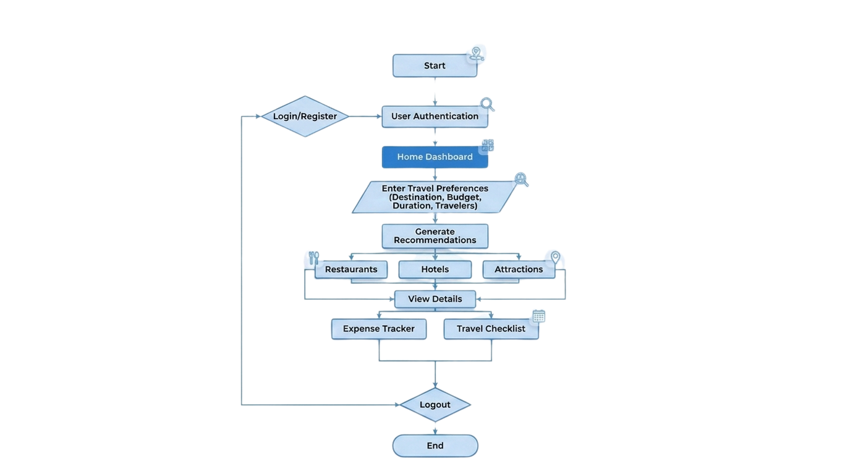

3.1.2 Admin Side
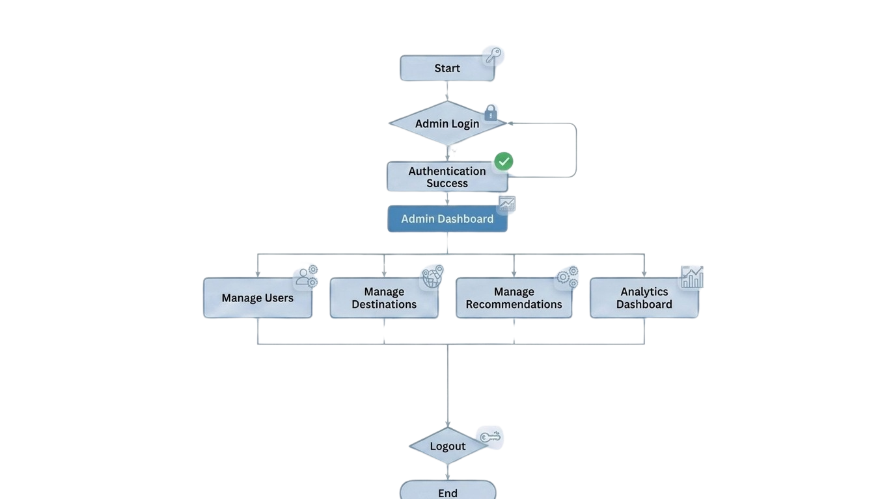

3.2 DFD Diagram
3.2.1 DFD Level 0
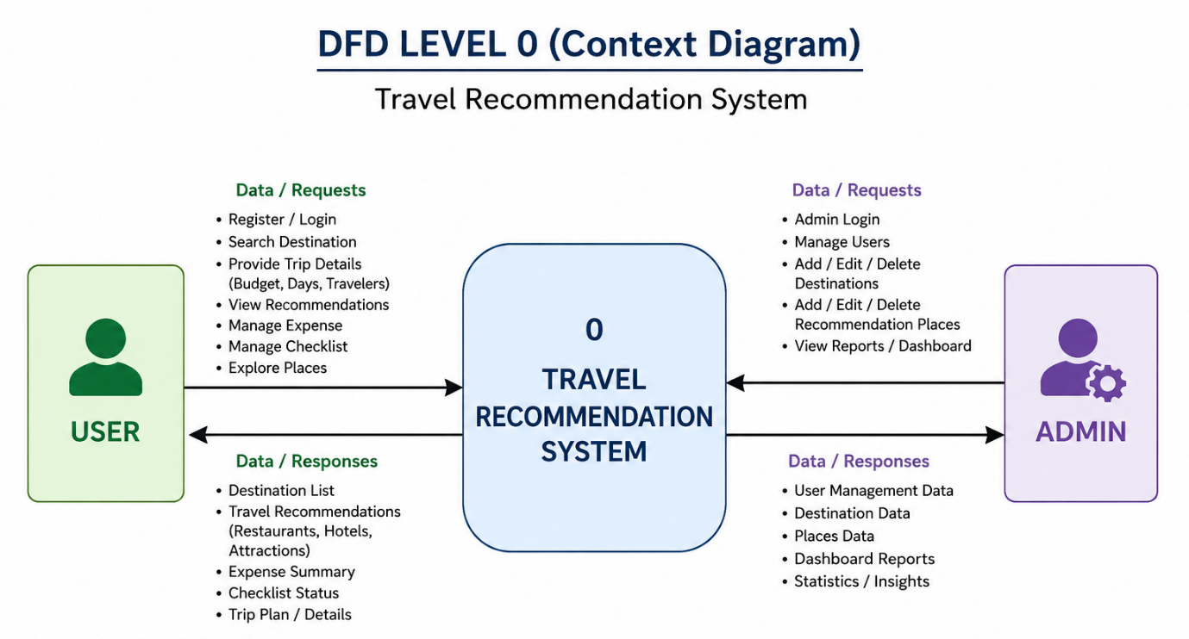
3.2.2 DFD Level 1
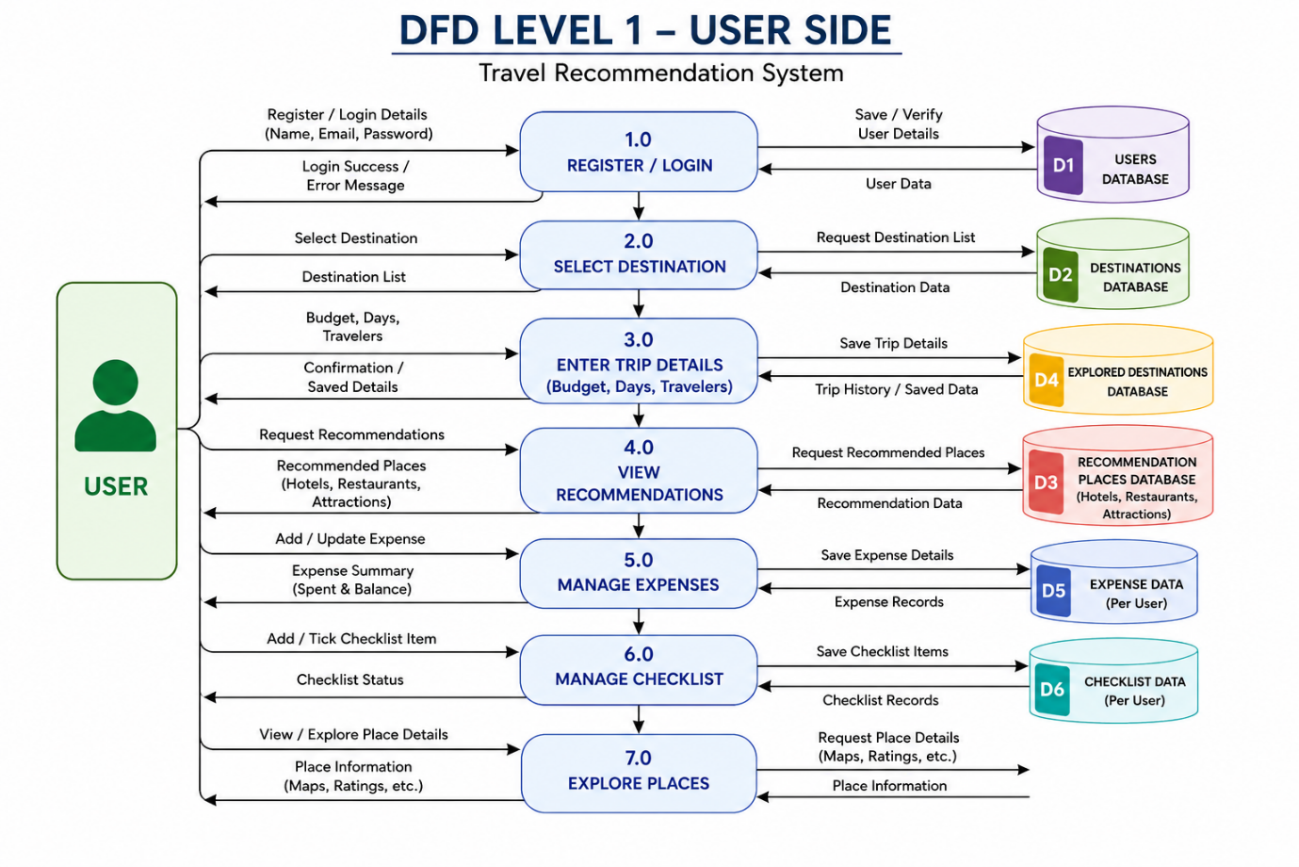

3.2.3 DFD Level 2
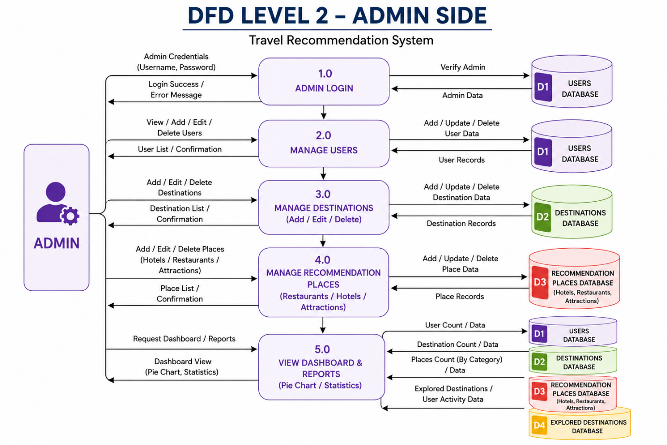

3.3 Table Structure
Table 3.3.1 User Table
Field Name | Data Type | Key | Description
id | INTEGER | Primary Key | Unique User ID
name | VARCHAR(100) | Not Null | User Name
email | VARCHAR(150) | Unique | User Email
password | VARCHAR(255) | Not Null | Encrypted Password
created_at | DATETIME | - | Registration Date
is_admin | BOOLEAN | - | Admin or User

Table 3.3.2 Destinations Table
Field Name | Data Type | Key | Description
id | INTEGER | Primary Key | Unique Destination ID
destination_name | VARCHAR(100) | Unique | Destination Name
added_by_admin | BOOLEAN | - | Added by Admin
created_at | DATETIME | - | Added Date

Table 3.3.3 Recommendation_Places Table
Field Name | Data Type | Key | Description
id | INTEGER | Primary Key | Unique Place ID
destination_id | INTEGER | Foreign Key | Destination Reference
category | VARCHAR(50) | Not Null | Restaurant / Hotel / Attraction
place_name | VARCHAR(150) | Not Null | Place Name
description | TEXT | - | Place Description
rating | FLOAT | Not Null | Place Rating
budget_tier | VARCHAR(20) | - | Low / Medium / High
image_url | TEXT | Not Null | Image Link
google_maps_link | TEXT | Not Null | Google Maps Link
added_by_admin | BOOLEAN | - | Added by Admin
created_at | DATETIME | - | Added Date

3.4 Menu Design
1.
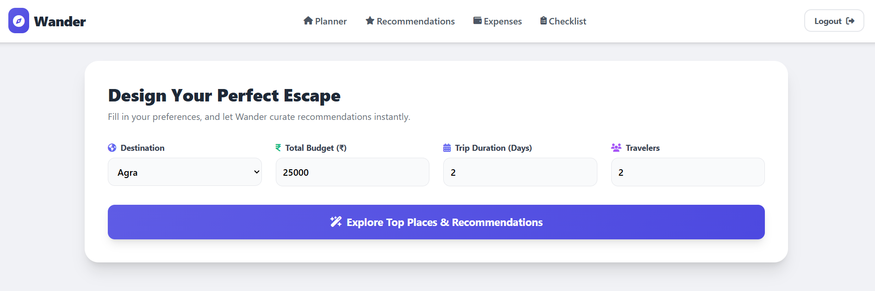

1. Register Page
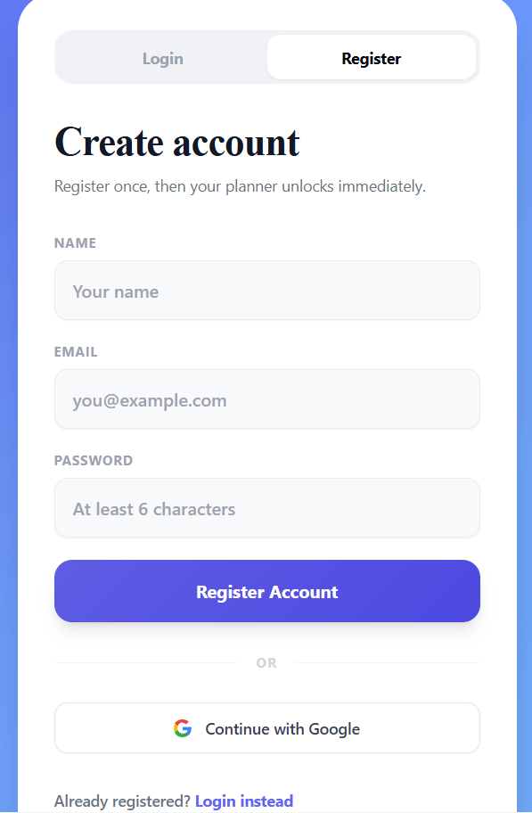
2. Login Page
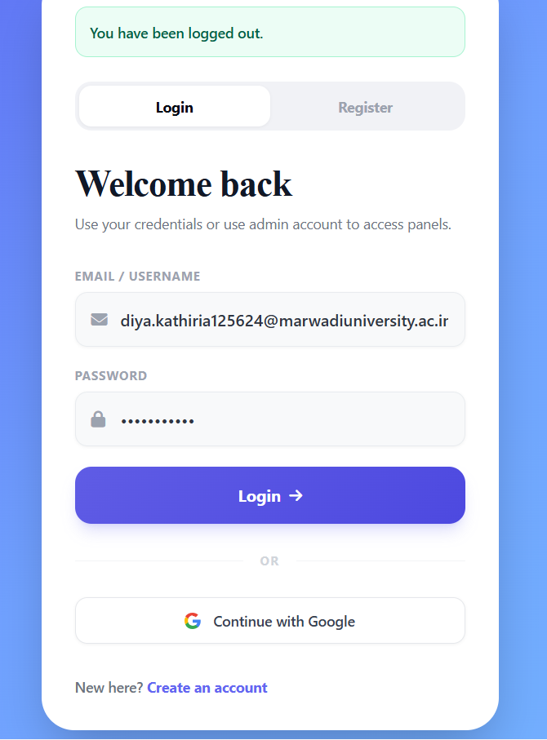

3. User Dashboard


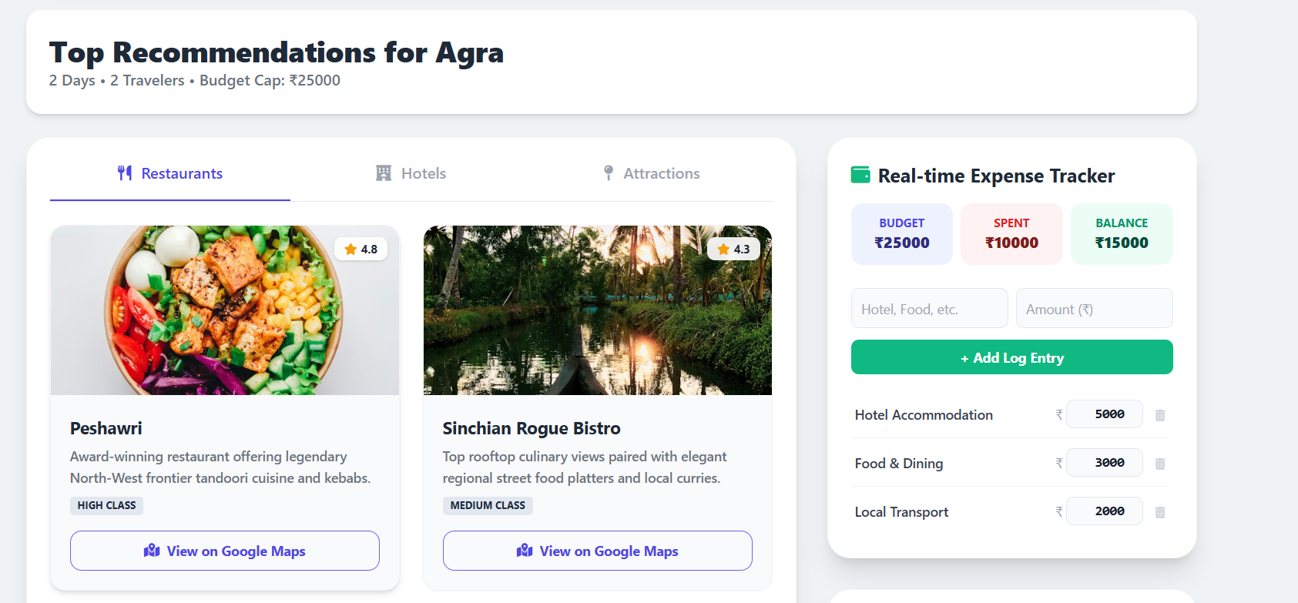

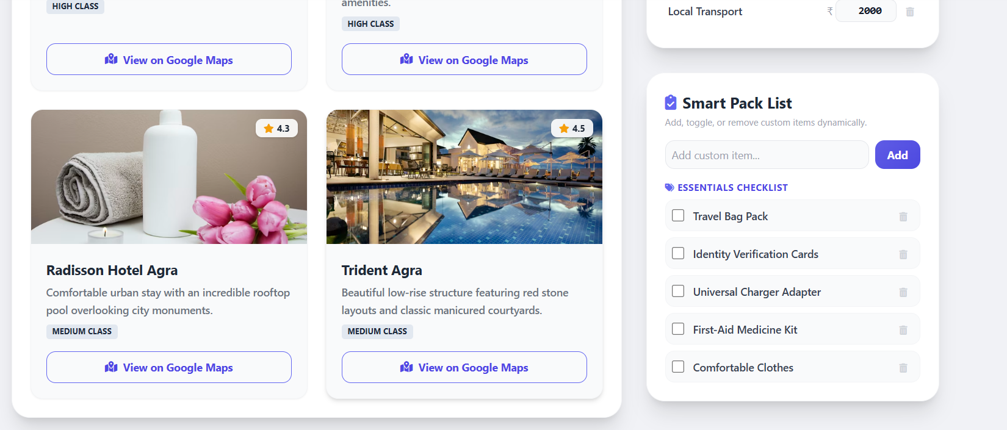

4. Admin Dashboard
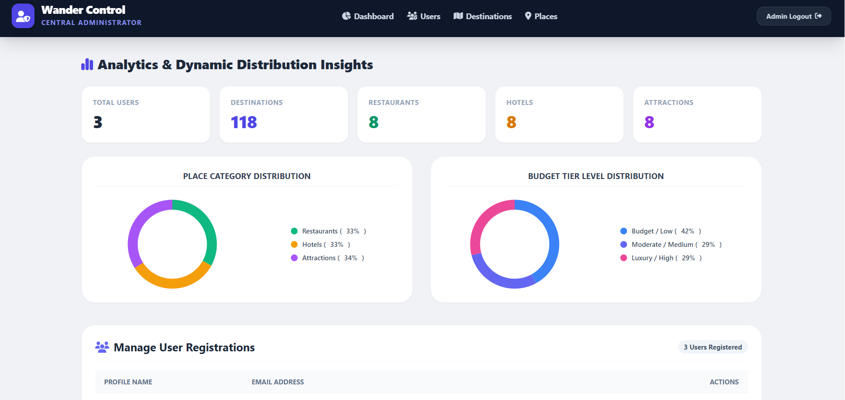
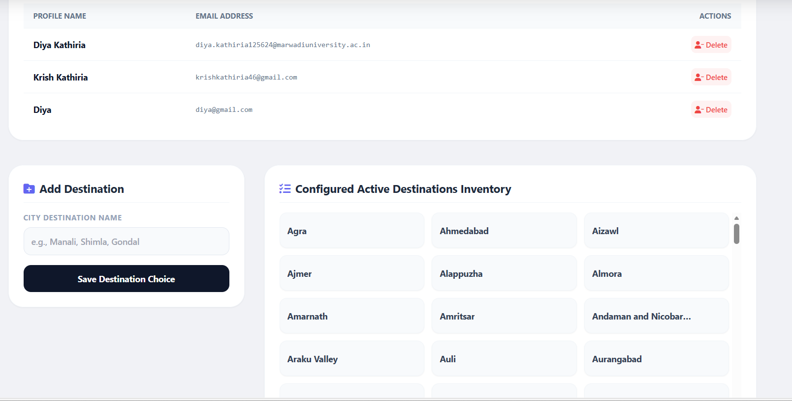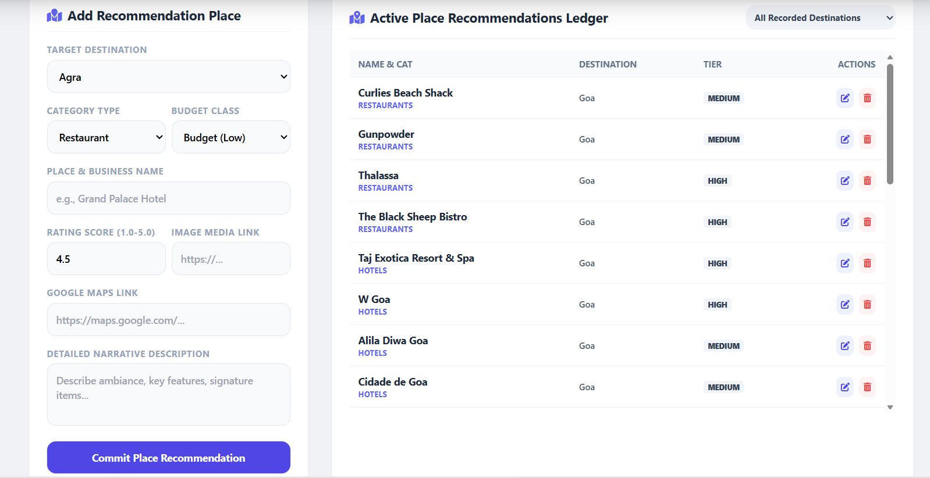

4. CONCLUSION

The Travel Recommendation System successfully provides a simple and effective solution for planning and managing travel activities. It helps users discover suitable destinations, hotels, restaurants, and tourist attractions based on their travel preferences, budget, and trip requirements. By bringing all travel-related information together on a single platform, the system reduces the effort and time required for trip planning.
The project improves the overall travel experience by providing personalized recommendations, travel planning tools, expense tracking, and smart packing assistance. Users can easily organize their trips, monitor their travel budget, and access important travel information from one place. The integration of destination recommendations, accommodation details, dining options, and tourist attractions makes travel planning more convenient and efficient.
The Admin Panel further enhances the system by allowing administrators to manage users, destinations, hotels, restaurants, and attractions efficiently. Analytical charts and dashboard reports help maintain and monitor the overall system effectively. The use of Python Flask and SQLite database ensures reliable data management, smooth performance, and secure storage of travel information.
Overall, the project successfully achieves its objective of creating a smart and user-friendly Travel Recommendation System. It provides practical solutions for travelers while demonstrating the implementation of web development, database management, user authentication, and recommendation-based systems. The project is useful for both academic learning and real-world travel planning applications and can be further enhanced with advanced features such as AI-based recommendations, real-time weather integration, online booking services, and mobile application support in the future.

5. LEARNING DURING PROJECT WORK

• Learned Web Development using HTML, CSS, and JavaScript
During the development of this project, we gained practical knowledge of frontend web development using HTML, CSS, and JavaScript. We learned how to design responsive web pages, create interactive user interfaces, and improve user experience through proper layout and styling techniques. We also learned how JavaScript is used to handle user interactions and dynamic webpage functionality.

• Learned Backend Development using Python Flask
We learned how to develop the backend of a web application using Python Flask. This included creating routes, handling user requests, processing form data, managing application logic, and connecting the frontend with the database. Flask helped us understand how web applications function on the server side.

• Learned Database Design and Management using SQLite
This project provided practical experience in designing and managing databases using SQLite. We learned how to create tables, define relationships between data, store information efficiently, and retrieve records when required. We also learned how to perform database operations such as insertion, updating, deletion, and searching of records.

• Improved Understanding of User Authentication Systems
While implementing the login and registration functionality, we learned the importance of user authentication and security. We understood how user credentials are validated, how sessions are managed, and how secure access to application features is maintained. We also gained experience with Google Sign-In integration.

• Learned CRUD Operations and Database Integration
We gained practical knowledge of CRUD (Create, Read, Update, Delete) operations through various modules of the system. We learned how users and administrators can add, view, update, and delete information such as destinations, hotels, restaurants, attractions, and travel plans while maintaining database consistency.

• Gained Experience in UI/UX Design
The project helped us understand the importance of designing an attractive and user-friendly interface. We learned how proper layouts, colors, icons, navigation menus, and responsive design improve usability. We focused on creating a simple and intuitive interface to enhance the overall user experience.

• Learned Project Planning and Documentation
During the development process, we learned how to plan a software project systematically. This included requirement gathering, module identification, database design, interface planning, testing, and documentation. We also understood the importance of maintaining proper project reports and technical documents.

• Improved Problem-Solving and Debugging Skills
Developing the project involved solving various technical challenges and fixing coding errors. We learned how to identify bugs, analyze error messages, test application functionality, and implement appropriate solutions. This significantly improved our logical thinking and troubleshooting abilities.

• Understood Client-Server Architecture
Through the implementation of the Travel Recommendation System, we learned how client-server architecture works. We understood how the frontend sends requests to the backend, how the server processes those requests, interacts with the database, and returns the required information to users.

• Learned Software Development Life Cycle (SDLC) Concepts
The project provided practical exposure to various phases of the Software Development Life Cycle, including planning, analysis, design, development, testing, deployment, and maintenance. Understanding these phases helped us develop the project in a structured and organized manner while following software engineering principles.

6. BIBLIOGRAPHY

6.1 Online Reference

- For Interface , GUI and I user Pinterest and https://dribbble.com
- For Code I used https://claude.ai/new and https://gemini.google.com//
- Unsplash Images (Travel Images Reference) https://unsplash.com
- Google Maps Platform Documentation https://www.google.com/maps

6.2 Offline Reference

- College lecture notes
- Faculty Guidance

